**PROJECTBASED SKILLING REPORT**

**On**

***Online Share Trading***

**Submitted in partial fulfilment of the**

**Requirements for the award of the Degree of**

**Bachelor of Technology**

**In**

**Computer Science & Engineering**

**By**

|  |  |
| --- | --- |
| **P.PRAVALLIKA**  **(170031056)**  **P.PRANITHA** | **P.PRASUNA**  **(170031064)**  **R.YASHASWINI** |
| **(170031065)** | **(170031095)** |



**DEPARTMENT OF COMPUTER SCIENCE AND ENGINEERING**

**(DST-FIST Sponsored Department)**

**K L University**

Green Fields, Vaddeswaram, Guntur District-522 502

**2016-2017**

**K L University**

**DEPARTMENT OF COMPUTER SCIENCE AND ENGINEERING**

**(DST-FIST Sponsored Department)**



***CERTIFICATE***

This is to certify that this project based skilling report entitled **“ONLINE SHARE TRADING”**is a bonafide work done By (**170031095**)in partial fulfillment of the requirement for the award of degree in **BACHELOR OF TECHNOLOGY** in **Computer Science and Engineering** during the academic year 2018-2019.

**Faculty In Charge Head of the Department**

**K L University**

**DEPARTMENT OF COMPUTER SCIENCE AND ENGINEERING**

**(DST-FIST Sponsored Department)**



***DECLARATION***

We hereby declare that this project based skilling report entitled **“ONLINE SHARE TRADING”** has been prepared by us in partial fulfillment of the requirement for the award of degree “**BACHELOR OF TECHNOLOGY in COMPUTERSCIENCE AND ENGINEERING**” during the academic year 2018-2019.

I also declare that this project based skillingreport is of our own effort and it has not been submitted to any other university for the award of any degree.

|  |  |
| --- | --- |
| **Name** | **Student ID** |
| **170031056** | **P.PRAVALLIKA** |
| **170031064** | **PRASSUNA** |
| **170031065** | **PRANITHA** |
| **170031095** | **R.YASHASWINI** |

**Date: 26/03/19**

**Place:VADDESWARAM**

**ACKNOWLEDGEMENTS**

My sincere thanks to XXXXXfor rendering outstanding support throughout the project for the successful completion of the work.

We express our gratitude to **Dr.V. Harikiran,** Head of the Department for Computer Science and Engineering for providing us with adequate facilities, ways and means by which we are able to complete this project work.

We would like to place on record the deep sense of gratitude to the honourable Vice Chancellor, K L University for providing the necessary facilities to carry the concluded project work.

Last but not the least, we thank all Teaching and Non-Teaching Staff of our department and especially my classmates and my friends for their support in the completion of our project work.

|  |  |
| --- | --- |
| **Name** | **Student ID** |
| **170031056** | **P.PRAVALLIKA** |
| **170031064** | **PRASSUNA** |
| **170031065** | **PRANITHA** |
| **170031095** | **R.YASHASWINI** |

TABEL OF CONTENTS

ABSTRACT 5

INTRODUCTION 6

PROJECT DESCRIPTION 8

List of Entities & Attributes 9

ER Diagram (Conceptual Model) 11

Schema Diagram 12

Normalization & Final List of Relations 14

Create & Insert SQL Queries 17

SQL Queries related to Report Generation 20

Conclusion 22

**ABSTRACT:**

Online trading of shares and DMAT account All the leading banks in India are providing De-materialization (DMAT) accounts to their customers. The criteria for getting DMAT account is the customer requires SB account in the same bank in any branch. The DMAT will *provide the details of shares* holding in the account. The customer may sell or buy the shares from/to the account. The minimum criteria for buying shares are the customer requires amount required to buy shares. The criteria for selling shares the customer requires the balance of shares in DMAT account.

Procedure to Buy a share(s): The customer requires balance amount in the SB account, the required amount is to be blocked for buying shares from market. Customer will identify the shares from the stock market, the amount of shares required. The shares are to be purchased in two ways (1) Market price: The shares will be confirmed as per the current market price. (2) Limit price: The shares will be confirmed as the price will come down to limit price. Once the shares are confirmed, the required amount plus commission will be transferred to bank account. The shares will be transferred to DMAT account.

Procedure to sell share(s): The customer needs balance of shares in DMAT account. The customer will identify the shares needs to sell in the market. The shares are to be sold in two ways. (1) Market price: The shares will be confirmed as per the current market price. (2) Limit price: The shares will be confirmed as the price will reach the limit price. The sold shares will be transferred to bank account. The amount minus commission will be transferred to bank account.

**Questions:**

**Q1)Identify major data requirements and consider the default aspects of the domain.**

**ANS:**

**Major data requirements:**

1. The criteria for getting DMAT account is the customer requires SB account in the same bank in any branch.
2. The criteria for selling shares the customer requires the balance of shares in DMAT account.
3. The shares are to be purchased in two ways (1) Market price: The shares will be confirmed as per the current market price. (2) Limit price:

**Default aspects of the domain:**

1. The minimum criteria for buying shares are the customer requires amount required to buy shares.
2. In procedure of buying shares:

Once the shares are confirmed, the required amount plus commission will be transferred to bank account.

1. In procedue of selling shares:
2. The sold shares will be transferred to bank account. The amount minus commission will be transferred to bank account.

**Q2)Identify the Entities in the description.**

ANS:

**The entities from the above description are:**

a)BANK_ACCOUNT

b)SHARES

c)CUSTOMER

d)DMAT_ACCOUNT

e)PRICE

**Q3) Identify the attributes to each of the Entities.**

ANS:

**The attributes for the entities are:**

a)BANK_ACCOUNT-Bank_id,Bank_address,Bank name

B) SHARES-share_id,balance

c)CUSTOMER-id,name,address,phonenumber

d)DMAT_ACCOUNT-Dmat_id, Dmat_loc

e)Price-Market price,limit price

**Q4) Identify the Relationship between the entities as mentioned in the description.**

**RELATIONSHIPS:**

1)customer **REQUIRES** sb_account

2)dmat_account **PROVIDES** details of shares

3) shares **CONFIRMED AS PER THE** current market price.

4) The customer **IDENTIFIES**  the shares .

5)shares are **BOUGHTFROM**  bank account.

**Q5)Develop ER models as part of conceptual design.**

**ER-DIAGRAM:**

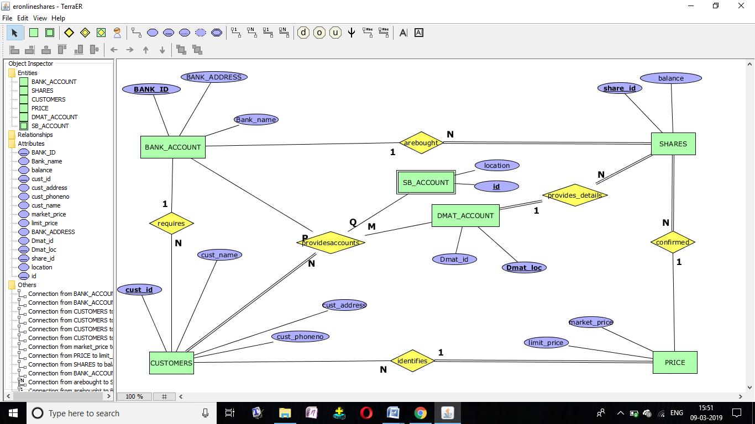

**ASSUMPTIONS:**

1. Can a customer can have shares in both DMAT_Account and Bank_Account.
2. Do all the shares of the customers are confirmed as per the current market price.
3. Does the DMAT_Account and SB_Account can be the attributes of bank_account.

**Q6)Realize the ER models into schemas as part of logical design.**

BANK_ACCOUNT

|  |  |  |
| --- | --- | --- |
| Cust_id | Bank_address | Bank_name |

SHARES

|  |  |
| --- | --- |
| Shares_id | Balance |

Customer

|  |  |  |  |
| --- | --- | --- | --- |
| Cust_id | Cust_name | address | Phone_number |

DMAT_account

|  |  |
| --- | --- |
| Shares_id | DMAT_location |

PRICE

|  |  |  |
| --- | --- | --- |
| Bank_id | Market_price | Limit_price |

**Q7) Create tables with constraints to the identified schemas as part of logical design.**

Create table bankaccount(custid int primary key,bankadd varchar,bankname varchar)

Create table shares(shareid int primary key,balance int)

Create table customer(custid int primary key,custname varchar,address varchar, foreign key custid references bankaccount(custid))

Create table dmat(int sharesid,loc varchar,foreign key sharesid references shares(shareid))

Create table price(bankid int primary key,marketprice int,limitprice int)

**CREATING TABLES:**

SQL> create table bankaccount(custid int primary key,bankadd varchar(5),bankname varchar(5));

Table created.

SQL> create table shares(shareid int primary key,balance int);

Table created.

SQL> create table customer(custid int,custname varchar(5),address varchar(5),foreign key(custid) references bankaccount(custid));

Table created.

create table dmat(shareid int,loc varchar(5),foreign key(shareid) references shares(shareid));

Table created.

SQL> create table price(bankid int primary key,marketprice int,limitprice int);

Table created.

**INSERTING VALUES INTO TABLES:**

SQL> insert into bankaccount values(&custid,'&bankadd','&bankname');

Enter value for custid: 1

Enter value for bankadd: GUN

Enter value for bankname: sbi

old 1: insert into bankaccount values(&custid,'&bankadd','&bankname')

new 1: insert into bankaccount values(1,'GUN','sbi')

1 row created.

SQL> /

Enter value for custid: 2

Enter value for bankadd: vig

Enter value for bankname: ABC

old 1: insert into bankaccount values(&custid,'&bankadd','&bankname')

new 1: insert into bankaccount values(2,'vig','ABC')

1 row created.

SQL> /

Enter value for custid: 3

Enter value for bankadd: kri

Enter value for bankname: XYZ

old 1: insert into bankaccount values(&custid,'&bankadd','&bankname')

new 1: insert into bankaccount values(3,'kri','XYZ')

1 row created.

SQL> /

Enter value for custid: 4

Enter value for bankadd: raj

Enter value for bankname: CBI

old 1: insert into bankaccount values(&custid,'&bankadd','&bankname')

new 1: insert into bankaccount values(4,'raj','CBI')

1 row created.

SQL> select *from bankaccount;

CUSTID BANKA BANKN

---------- ----- -----

1 GUN sbi

2 vig ABC

3 kri XYZ

4 raj CBI

SQL> insert into shares values(&shareid,&balance);

Enter value for shareid: 1

Enter value for balance: 500

old 1: insert into shares values(&shareid,&balance)

new 1: insert into shares values(1,500)

1 row created.

SQL> /

Enter value for shareid: 2

Enter value for balance: 600

old 1: insert into shares values(&shareid,&balance)

new 1: insert into shares values(2,600)

1 row created.

SQL> /

Enter value for shareid: 3

Enter value for balance: 800

old 1: insert into shares values(&shareid,&balance)

new 1: insert into shares values(3,800)

1 row created.

SQL> /

Enter value for shareid: 4

Enter value for balance: 700

old 1: insert into shares values(&shareid,&balance)

new 1: insert into shares values(4,700)

1 row created.

SQL> select *from shares;

SHAREID BALANCE

---------- ----------

1 500

2 600

3 800

4 700

SQL> insert into customer values(&custid,'&custname','&address');

Enter value for custid: 1

Enter value for custname: yashu

Enter value for address: uk

old 1: insert into customer values(&custid,'&custname','&address')

new 1: insert into customer values(1,'yashu','uk')

1 row created.

SQL>

SQL> /

Enter value for custid: 2

Enter value for custname: bob

Enter value for address: swis

old 1: insert into customer values(&custid,'&custname','&address')

new 1: insert into customer values(2,'bob','swis')

1 row created.

SQL> /

Enter value for custid: 3

Enter value for custname: kat

Enter value for address: swede

old 1: insert into customer values(&custid,'&custname','&address')

new 1: insert into customer values(3,'kat','swede')

1 row created.

SQL> /

Enter value for custid: 4

Enter value for custname: goan

Enter value for address: paris

old 1: insert into customer values(&custid,'&custname','&address')

new 1: insert into customer values(4,'goan','paris')

1 row created.

SQL> select *from customer;

CUSTID CUSTN ADDRE

---------- ----- -----

1 yashu uk

2 bob swis

3 kat swede

4 goan paris

SQL> insert into dmat values(&shareid,'&loc');

Enter value for shareid: 1

Enter value for loc: nagar

old 1: insert into dmat values(&shareid,'&loc')

new 1: insert into dmat values(1,'nagar')

1 row created.

SQL> /

Enter value for shareid: 2

Enter value for loc: hyd

old 1: insert into dmat values(&shareid,'&loc')

new 1: insert into dmat values(2,'hyd')

1 row created.

SQL> /

Enter value for shareid: 3

Enter value for loc: vij

old 1: insert into dmat values(&shareid,'&loc')

new 1: insert into dmat values(3,'vij')

1 row created.

SQL> /

Enter value for shareid: 4

Enter value for loc: nell

old 1: insert into dmat values(&shareid,'&loc')

new 1: insert into dmat values(4,'nell')

1 row created.

SQL> select *from dmat;

SHAREID LOC

---------- -----

1 nagar

2 hyd

3 vij

4 nell

SQL> insert into price values(&bankid,&marketprice,&limitprice);

Enter value for bankid: 10

Enter value for marketprice: 100000

Enter value for limitprice: 20000

old 1: insert into price values(&bankid,&marketprice,&limitprice)

new 1: insert into price values(10,100000,20000)

1 row created.

SQL> /

Enter value for bankid: 20

Enter value for marketprice: 500000

Enter value for limitprice: 100003

old 1: insert into price values(&bankid,&marketprice,&limitprice)

new 1: insert into price values(20,500000,100003)

1 row created.

SQL> /

Enter value for bankid: 30

Enter value for marketprice: 865200

Enter value for limitprice: 12543

old 1: insert into price values(&bankid,&marketprice,&limitprice)

new 1: insert into price values(30,865200,12543)

1 row created.

SQL> /

Enter value for bankid: 40

Enter value for marketprice: 4562031

Enter value for limitprice: 25410

old 1: insert into price values(&bankid,&marketprice,&limitprice)

new 1: insert into price values(40,4562031,25410)

1 row created.

SQL> select *from price;

BANKID MARKETPRICE LIMITPRICE

---------- ----------- ----------

10 100000 20000

20 500000 100003

30 865200 12543

40 4562031 25410

**QUERIES:**

**SQL> select custid,custname from customer where address='uk';**

CUSTID CUSTN

---------- -----

1 yashu

**SQL> select count(*) from price where marketprice=4562031;**

COUNT(*)

----------

1

**SQL> update bankaccount set bankadd='gulf' where custid=1;**

1 row updated.

SQL> select *from bankaccount;

CUSTID BANKA BANKN

---------- ----- -----

1 gulf sbi

2 vig ABC

3 kri XYZ

4 raj CBI

**SQL> select bankid from price where marketprice between 100000 and 500000;**

BANKID

----------

10

20

**SQL> select sum(balance) as total_balance from shares;**

TOTAL_BALANCE

-------------

2600

**SQL> select custid,address from customer where custname like 'y%';**

CUSTID ADDRE

---------- -----

1 uk

**SQL> select max(limitprice) from price;**

MAX(LIMITPRICE)

---------------

100003

**SQL> select min(balance) from shares;**

MIN(BALANCE)

------------

500

**SQL> select b.bankadd from bankaccount b where b.custid in(select c.custid from customer c where c.custname='bob');**

BANKA

-----

Vig

**SQL> select bankid from price where limitprice>all(select limitprice from price);**

no rows selected